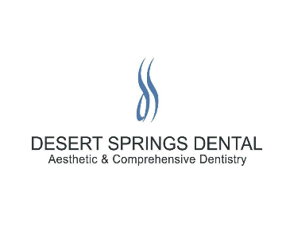
UNDERSTANDING YOUR DENTAL INSURANCE

It is our pleasure to assist in maximizing your insurance benefits by completing your claim forms. As a courtesy, in addition to filling the claim, we will only ask initially for you to pay your estimated copayment and not the full amount due. Please understand that the fees for your dental services are 100% your responsibility regardless of dental insurance reimbursement. Treatment and financial estimates are subject to change if the dental procedures are altered in any way. Please understand that due to the difference in insurance company’s allowed fee schedules we are only able to estimate your percentage due on the day of your appointment and our estimate with you. The difference will be due upon receipt of our statement. Any overpayments by you will be reimbursed to you when dental treatment has been completed.
Your dental insurance coverage is not based on what you need or what your dentist recommends; It is based on how much your employer pays into the plan, and the terms and limitations of your specific plan. Some planes cover as little as 30% or as much as 100% of dental services, with most falling in the 40% to 80% range.
Most plans are the amount of benefit on a fee schedule arbitrarily developed by insurance companies and they do not share this information with us. For this reason, you may receive a lower percentage than the reimbursement level indicated in your dental plan. For example, if your plan states that it will cover 80% of the cost of a specific procedure, it means 80% of the arbitrarily determined fee by the insurance company and not the actual fee charged by your office.
The financial obligation for dental treatment is between you and our office. The insurance company is responsible to you and not our office.
Understand that our office does not submit “pre-authorizations” to any dental insurance company due to the fact that dental insurance never guarantees payment even with “pre-authorization”.

Signature Print Name Date

